**INTERNSHIP REPORT**

MINISTRY OF MICRO,SMALL AND

MEDIUM ENTERPRISES

**(MSME)**

**EMBEDDED SYSTEMS**

**SUBMITTED BY:**

HARIHARAN T S

727722EUEC051

DEPARTMENT OF ECE

SRI KRISHNA COLLEGE OF

ENGINEERING AND TECHNOLOGY

COIMBATORE-641008

**ACKNOWLEDGEMENT**

I would like to extend my sincere gratitude to MSME for providing me with the invaluable opportunity to intern with their esteemed organization. My internship experience has been immensely enriching, allowing me to gain valuable insights and skills in [specific area of experience]. I am particularly grateful for the support and guidance extended by my supervisors and colleagues throughout this journey.

I would like to express my heartfelt thanks to [Mentor's Name] for their exceptional mentorship and unwavering support during my tenure at MSME. Their guidance has been instrumental in shaping my professional growth and enhancing my skills.

I am truly appreciative of the trust MSME has placed in me and the learning opportunities provided, which have equipped me with confidence for future endeavors. I look forward to applying the knowledge and experiences gained during my internship to contribute effectively in my career.

**ABOUT THE COMPANY**

MSME Technology Development Centre is at the forefront of innovation and technological advancement within the MSME sector. Renowned for its expertise in embedded systems and commitment to excellence, the centre serves as a pivotal resource for MSMEs seeking to enhance their technological capabilities and competitive edge. With state-of-the-art facilities and a dedicated team of professionals, MSME Technology Development Centre fosters a culture of innovation and collaboration, enabling MSMEs to develop and deploy cutting-edge technologies that drive industry transformation. The centre's strategic initiatives and proactive support systems have established it as a cornerstone of entrepreneurial growth and economic development, empowering MSMEs to thrive in a rapidly evolving marketplace.

**BASIC STRUCTURE OF EMBEDDED SYSTEM**

An embedded system is a specialized computing system that performs dedicated functions or tasks within a larger mechanical or electrical system. It is designed to perform specific operations, often with real-time computing constraints. Here's a basic structure of an embedded system:

An embedded system is a specialized computing system that performs dedicated functions or tasks within a larger mechanical or electrical system. It is designed to perform specific operations, often with real-time computing constraints. Here's a basic structure of an embedded system:

**1. Microcontroller or Microprocessor**

* The heart of the embedded system.
* Microcontroller: Includes a CPU, memory, and peripherals on a single chip (e.g., PIC, AVR, ARM Cortex-M).
* Microprocessor: Typically used in more complex systems, with separate memory and peripheral components (e.g., ARM Cortex-A).

**2. Memory**

* **ROM (Read-Only Memory)**: Stores firmware or software that does not change.
* **RAM (Random Access Memory)**: Used for temporary data storage and processing.

**3. Input Devices**

* Sensors (e.g., temperature, pressure, light).
* Keypads, buttons, touch screens.

**4. Output Devices**

* Displays (LCD, LED).
* Actuators (motors, relays).
* Speakers.

**5. Power Supply**

* Provides the necessary power to the microcontroller and other components.
* Can be battery-powered or connected to a power adapter.

**6. Peripherals**

* Timers and counters.
* Analog-to-Digital Converters (ADC).
* Digital-to-Analog Converters (DAC).
* Pulse Width Modulation (PWM) units.

**7. Software/Firmware**

* The embedded code that runs on the microcontroller.
* Written in languages like C, C++, or assembly.
* Real-Time Operating System (RTOS) for handling multiple tasks and ensuring real-time performance.

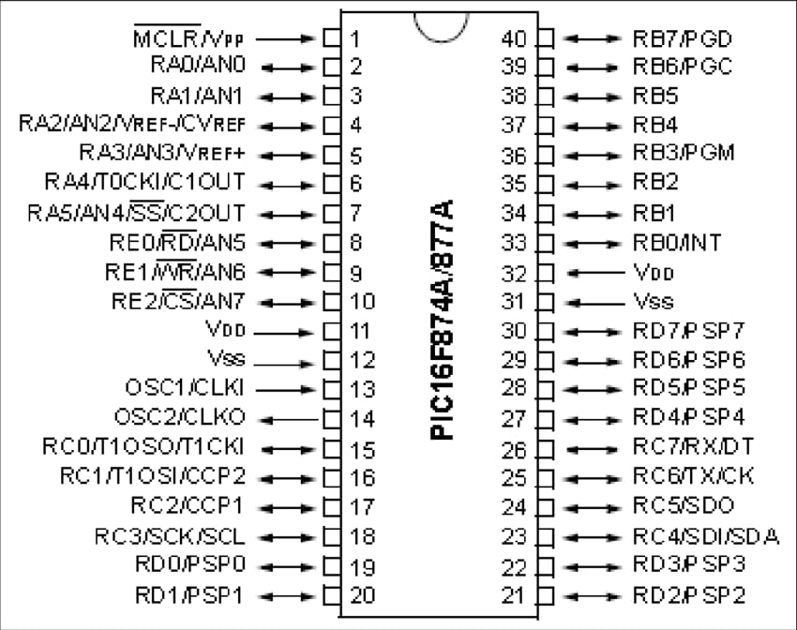**PIN DAIGRAM**

**PIC16F877A PIN DETAILS**

1 - MCLR/VPP - MCLR is used during programming, mostly connected to programmers like pichit.

2 - RAD/ANO - Analag peno or om pin of PORTA.

3 - RAI/ANI - Analog pin 1 or 1th pin of PORTA.

4 - RA2/AN2/Vret - Analag pins or and pur of PORTA.

5 - RA3/AN3/Vrett - Analag pins or zed pin of PORTA.

6 - RAW/AN/Clout - 14th pen of PORTA.

7 - RAS/AN4/C2Out - Analog pin 4 or sth pen of PORTA.

8. REO/RD/ AN5 - Analog pin sa om på of PORTE.

9. REI/DOR/AN6 - Analog pin 6 or in por of PORTE.

10. REZ/CS/AN7 - Analog pin 7 or and pir of PORTE.

11. Vdd - Ground por of MCQ

12. Vss - positive pin of mcu (+5V).

13. OSC1/CLK1 - External oscillator / dock input pin.

14. OSC2/CLK2 - External oscillator / clack output pin.

15. PCO/TIOSO - 0th pen of PORTC.

16. RC1/TIOS1/CCP2 - 1st pin of PORTC a Timer / PWM pin.

17. RL2/CCP1 - 2nd pin of PORTC or Timer/PWM pin.

18. RC3/SCK/SCL - 3rd pin of PORTC.

19. RDO/PSP0 - 0th pin of PORTD.

20. RDI/PSP1 - 1th pin of PORTD.

21. RD2/PSP2 - 2th pin of PORTD.

22. RD3/PSP3 – 3rd pin of PORTD.

23. RD4/SDI/SDA - 4th pin of PORT C

24. RC5 /Tx(CK ) - 5th pin of PORT C or Transmitter

25. RL6/TX CK - 6th pin of PORTC.

26. RCT/RX/DT - 7th pin of PORTC or receiver pin of Microcontroller.

27. RD4/PSP4 - 4th pin of PORTO.

28. RDS/PSP5 – 5th pin of PORTD.

29. RD6/PSP6 - 6th pin of PORTD.

30. RD7/PSP7 - 7th pin of PORTD.

31. Vss - the pin of MCU (+5V).

32. Vdd - Ground pir of MCU.

33. RBO/INT - 0th pin of PORTE a connected to program.

34.RB1 - 1st pin of PORTB.

35. RB2 - 2nd pin of PORTB.

36. RB3/ PGM- 3rd pin of PORTB of connected to programmer.

37. RB4 – 4th pin of PORTB

38. RB5 - 5th pin of PORTB

39. RB6/PGC - 6th pin of PORTB or connected to programmer.

40. RB7/PGB- The per of PORTB or connected to programmer.

**SOFTWARE USED**

### ISIS

ISIS is a part of the Proteus Design Suite, which is used for electronic design automation (EDA). The main uses of ISIS include:

**1.Schematic Capture**:

* Design and draw electronic circuits using a wide range of components.
* Create detailed schematics that represent electronic systems.

**2**.**Simulation**:

* Simulate the behavior of circuits, including microcontrollers and other programmable devices.
* Test and debug circuits virtually to ensure they function as intended before building physical prototypes.
* Includes support for a wide variety of microcontrollers, allowing for firmware testing within the simulation environment.

**3.Component Libraries**:

* Access extensive libraries of components, including both generic and manufacturer-specific parts.
* Easily incorporate these components into schematics and simulations.

**4.Educational Use**:

* Used widely in educational settings to teach students about circuit design and electronics.
* Provides a safe and cost-effective way for students to experiment with circuits.

**MPLAB**

MPLAB is an integrated development environment (IDE) for developing embedded applications on Microchip Technology's microcontrollers and digital signal controllers. The main uses of MPLAB include:

**Code Development**:

* Write, edit, and manage source code for embedded applications.
* Support for various programming languages, including C and assembly.

**Compilation and Building**:

* Compile and build code into executable files that can be loaded onto microcontrollers.
* Manage project dependencies and configurations.

**Debugging**:

* Debug applications using both software and hardware tools.
* Set breakpoints, watch variables, and step through code to identify and fix issues.
* Real-time debugging on actual hardware with supported debuggers.

**Simulation**:

* Simulate the behavior of microcontroller code within the MPLAB environment.
* Test and debug without the need for physical hardware, useful during early development stages.

**Hardware Support**:

* Support for a wide range of Microchip hardware tools, such as programmers (e.g., PICkit, MPLAB ICD) and evaluation boards.
* Direct programming and debugging on target hardware.

**Integration**:

* Integration with other Microchip tools and libraries to streamline the development process.
* Access to additional features and optimizations through plug-ins and extensions.

**TASKS**

**1.TRAFFIC LIGHT**

#include<pic.h>

#define _XTAL_FREQ 4000000

__CONFIG(0x3F72);

void main()

{

TRISB=0x00;

TRISD=0x00;

while(1)

{

PORTB=0x14;

PORTD=0x11;

__delay_ms(2000);

PORTB=0x24;

PORTD=0x11;

__delay_ms(1000);

PORTB=0x41;

PORTD=0x11;

__delay_ms(2000);

PORTB=0x41;

PORTD=0x12;

__delay_ms(1000);

PORTB=0x11;

PORTD=0x14;

__delay_ms(2000);

PORTB=0x11;

PORTD=0x24;

__delay_ms(1000);

PORTB=0x11;

PORTD=0x41;

__delay_ms(2000);

PORTB=0x12;

PORTD=0x41;

__delay_ms(1000);

}

}

**OUTPUT:**

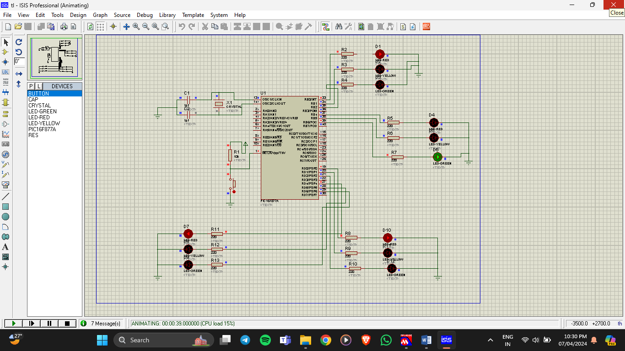

**2.7-SEGMENT DISPLAY:**

#include<pic.h>

#define _XTAL_FREQ 4000000

__CONFIG(0x3F72);

void main()

{

int setDigit[]={0X3F,0X06,0X5B,0X4F,0X66,0X6D,0X7D,0X07,0X7F,0X6F};

unsigned int digit1,digit2,digit3,digit4=0;

TRISB=0x00;

TRISD=0x00;

while(1)

{

for(int i=0;i<=9999;i++)

{

digit1=i%10;

digit2=(i%100)/10;

digit3=(i%1000)/100;

digit4=(i%10000)/1000;

PORTD=0x07;

PORTB=setDigit[digit1];

__delay_ms(10);

PORTD=0x0B;

PORTB=setDigit[digit2];

__delay_ms(10);

PORTD=0x0D;

PORTB=setDigit[digit3];

__delay_ms(10);

PORTD=0x0E;

PORTB=setDigit[digit4];

__delay_ms(10);

}

}

}

**OUTPUT:**

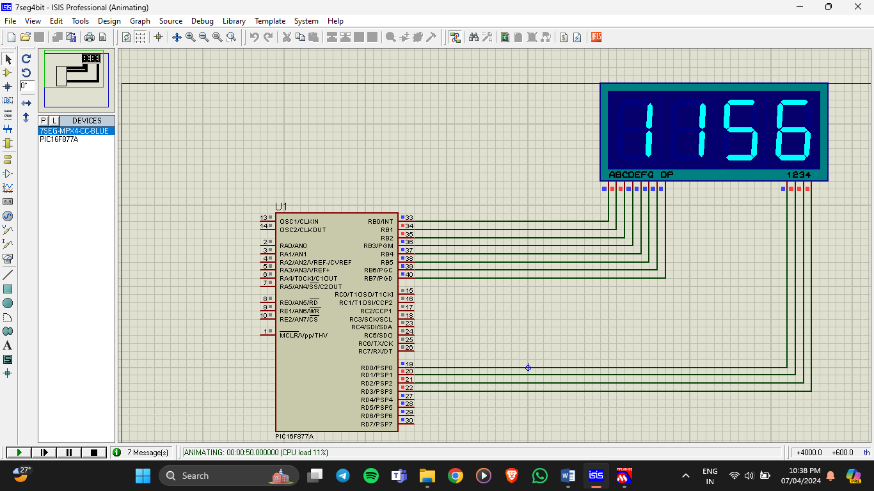

**3.ADC**

**HEADER FILE:**

#include<pic.h>

#define _XTAL_FREQ 4000000

#define RS RC0

#define E RC1

#define RS_dir TRISC0

#define E_dir TRISC1

#define LCD PORTD

#define LCD_dir TRISD

void display(char rs,char lcd)

{

RS=rs;

LCD=lcd;

E=1;

__delay_ms(10);

E=0;

__delay_ms(10);

}

void LCD_INIT()

{

display(0,0x38);

display(0,0x06);

display(0,0x0c);

display(0,0x01);

**PROGRAM:**

#include "lcd.h"

__CONFIG(0X3f72);

void main()

{

TRISA0=1;

ADCON0=0x01;

ADCON1=0x80;

TRISD=0x00;

TRISC0=0;

TRISC1=0;

unsigned int adc_value=0;

LCD_INIT();

int a,b,c,d;

while(1)

{

ADCON0=ADCON0 | 0x04;

while(ADCON0 & 0x04);

adc_value=ADRESH;

adc_value=(adc_value<<8) | ADRESL;

display(0,0x80);

display(1,'A');

display(1,'D');

display(1,'C');

display(1,':');

display(1,(adc_value/1000)+48);

a=(adc_value/100)%10;

display(1,a+48);

b=(adc_value/10)%10;

display(1,b+48);

display(1,(adc_value%10)+48);

}

}

**OUTPUT:**

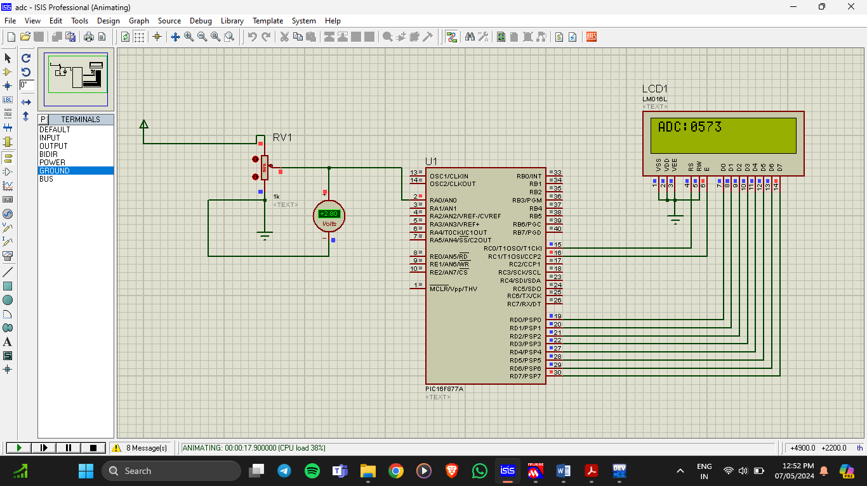

**4.LCD DISPLAY**

#include<pic.h>

__CONFIG(0X3F72);

#define _XTAL_FREQ 4000000

#define RS RC0

#define EN RC1

#define Data PORTD

#define DirRS TRISC0

#define DirEN TRISC1

#define DirData TRISD

void lcdInti(void)

{

DirRS=0;

DirEN=0;

DirData=0x00;

RS=0;

Data=0x38;

EN=1;

__delay_ms(10);

EN=0;

__delay_ms(10);

RS=0;

Data=0x06;

EN=1;

__delay_ms(10);

EN=0;

__delay_ms(10);

RS=0;

Data=0x0c;

EN=1;

__delay_ms(10);

EN=0;

__delay_ms(10);

RS=0;

Data=0x01;

EN=1;

__delay_ms(10);

EN=0;

__delay_ms(10);

}

void Display(char data, char rs)// m, 1

{

RS=rs;

Data=data;

EN=1;

__delay_ms(10);

EN=0;

__delay_ms(10);

}

void main()

{

lcdInti();

while(1)

{

Display(0x80,0);

Display('H',1);

Display('A',1);

Display('R',1);

Display('I',1);

Display('H',1);

Display('A',1);

Display('R',1);

Display('A',1);

Display('N',1);

Display(0xC0,0);

Display('D',1);

Display('O',1);

Display('B',1);

Display(':',1);

Display('2',1);

Display('0',1);

Display('.',1);

Display('0',1);

Display('6',1);

Display('.',1);

Display('2',1);

Display('0',1);

Display('0',1);

Display('4',1);

}

}

**OUTPUT:**

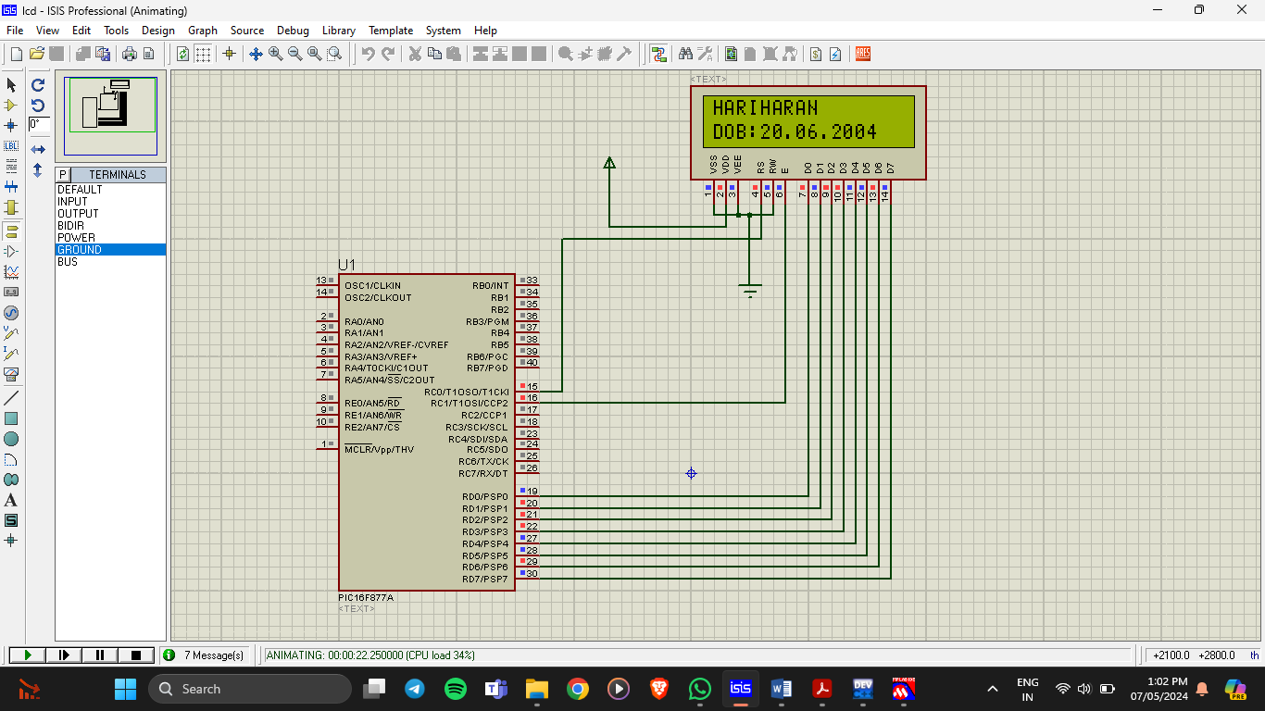

**5.KEYPAD**

#include<pic.h>

__CONFIG(0X3FFB);

#define _XTAL_FREQ 4000000

#define RS RC0

#define EN RC1

#define DATA PORTD

#define DIRRS TRISC0

#define DIREN TRISC1

#define DIRDATA TRISD

#define C1 RB0

#define C2 RB1

#define C3 RB2

#define R1 RB3

#define R2 RB4

#define R3 RB5

#define R4 RB6

#define DIRC1 TRISB0

#define DIRC2 TRISB1

#define DIRC3 TRISB2

#define DIRR1 TRISB3

#define DIRR2 TRISB4

#define DIRR3 TRISB5

#define DIRR4 TRISB6

void initial(void)

{

DIRRS=0;

DIREN=0;

DIRDATA=0;

RS=0;

DATA=0X38;

EN=1;

__delay_ms(10);

EN=0;

__delay_ms(10);

RS=0;

DATA=0X06;

EN=1;

__delay_ms(10);

EN=0;

__delay_ms(10);

RS=0;

DATA=0X0C;

EN=1;

__delay_ms(10);

EN=0;

__delay_ms(10);

RS=0;

DATA=0X01;

EN=1;

__delay_ms(10);

EN=0;

__delay_ms(10);

}

void display(int rs,char data)

{

RS=rs;

DATA=data;

EN=1;

__delay_ms(10);

EN=0;

__delay_ms(10);

}

void main()

{

initial();

int cc=0;

RS=0;

DATA=0X80;

EN=1;

__delay_ms(10);

EN=0;

__delay_ms(10);

DIRC1=0;

DIRC2=0;

DIRC3=0;

DIRR1=1;

DIRR2=1;

DIRR3=1;

DIRR4=1;

while(1)

{

C1=1,C2=0,C3=0;

if(C1==1&&C2==0&&C3==0)

{

if(R1==1)

{while(R1==1);

display(1,'1');

}

if(R2==1){

while(R2==1);

display(1,'4');

}

if(R3==1){

while(R3==1);

display(1,'7');

}

if(R4==1){

while(R4==1);

display(1,'*');

}

}

__delay_ms(50);

C1=0,C2=1,C3=0;

if(C1==0&&C2==1&&C3==0)

{

if(R1==1){

while(R1==1);

display(1,'2');

}

if(R2==1){

while(R2==1);

display(1,'5');

}

if(R3==1){

while(R3==1);

display(1,'8');

}

if(R4==1){

while(R4==1);

display(1,'0');

}

}

__delay_ms(50);

C1=0,C2=0,C3=1;

if(C1==0&&C2==0&&C3==1)

{

if(R1==1)

{while(R1==1);

display(1,'3');

}

if(R2==1){

while(R2==1);

display(1,'6');

}

if(R3==1){

while(R3==1);

display(1,'9');

}

if(R4==1){

while(R4==1);

display(1,'#');

}

}

__delay_ms(50);

}

}

**OUTPUT:**

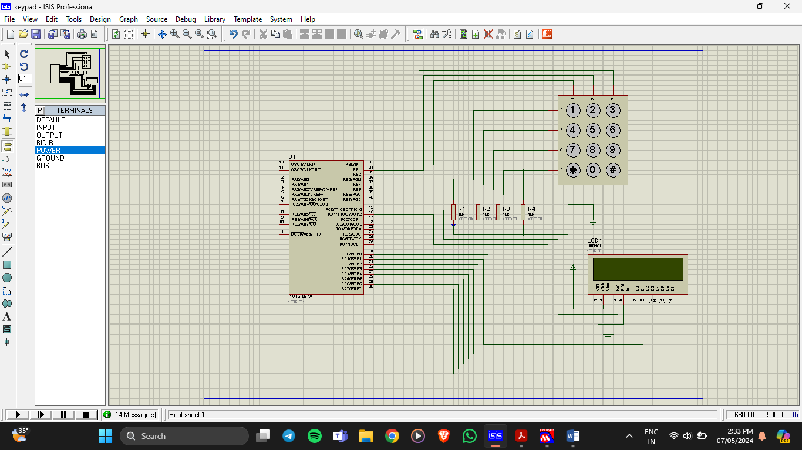

**FEEDBACK**

I am writing to express my gratitude and provide feedback regarding the Embedded System course conducted by Mr. Rajan at MSME. Over the past 10 days, we had the privilege of participating in an internship that was both enlightening and enriching.

Mr. Rajan's expertise in the field of embedded systems is truly commendable. His ability to break down complex concepts into understandable modules made the learning process smooth and engaging. His hands-on approach, combined with real-world examples, greatly enhanced our understanding and practical skills.

The course structure was well-organized, covering all essential aspects of embedded systems comprehensively. The practical sessions were particularly valuable, allowing us to apply theoretical knowledge and gain hands-on experience with various tools and technologies.

We also appreciate the excellent facilities and resources provided by MSME. The supportive environment and access to up-to-date equipment significantly contributed to our learning experience.

In summary, the Embedded System course exceeded our expectations. Mr. Rajan's exceptional teaching and the conducive learning environment at MSME have equipped us with valuable knowledge and skills that will undoubtedly benefit our future careers.

Thank you once again for this fantastic opportunity.